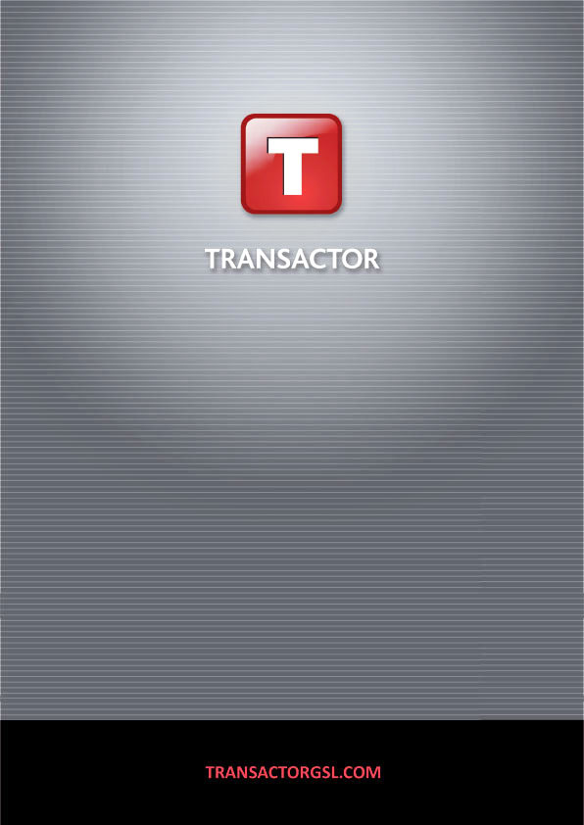

**Line of Business Project Definition**

**Tradesman Liability**

**Version** **9**

**Project Name:** **MLIAB**

**Created:** **24/12/2019**

**Definition Document Version: 1**

**Table of Contents**

1 Introduction 3

1.1 Introduction 3

1.2 Document Approval 3

2 Screen Order 4

2.1 Core Screens 4

3 Core Screen Information 6

3.1 Client Details 6

3.2 Business Details 7

3.3 Client Notes 8

3.4 Client Filing – Filing Codes Summary 9

3.5 Client Filing – Client Filing Codes 10

3.6 Contact & Marketing 11

3.7 Target Premium 12

3.8 Cross Sales 13

4 Data Capture Specification 14

5 Appendices – Property Glossary 15

6 Appendices – Full Project Properties 16

7 Appendices – Full Property Information by Screen 17

# Introduction

## Introduction

### About The Document

This document details the screen layouts, properties and data capture of the user project. For each screen in the project, the following information will be explained.

* Screen Layout – how the controls on the screen are laid out.
* Screen Notes – a selection of basic information about the screen.
* Screen Properties – the configuration and options chosen on the screen.
* Field Names – the description, name and type

Section 3 of the document details the behaviour of the core screens used within this project. The appendices contain full information about project settings and properties, along with database table information.

## Document Approval

|  |  |  |  |
| --- | --- | --- | --- |
| Name | Company | Date | Signature |
|  |  | …../..…/….. |  |
|  |  | …../..…/….. |  |
|  |  | …../..…/….. |  |
|  |  | …../..…/….. |  |
|  |  | …../..…/….. |  |

# Screen Order

## Core Screens

### New & Add Quote Navigations

The screens detailed in section 3 are included as part of a standard Transactor Line of Business project. The configuration of the screens can be altered using the Navigator Toolset. By default the screens are configured as below:

|  |  |  |  |
| --- | --- | --- | --- |
| Sequence Shown | Screen Name | Enabled By Default In Navigation Sets | |
| New Quote | Add Quote |
| 1 | Client Details |  | ❒ |
| 2 | Contact & Marketing Details |  |  |
| 3 | Target Premium |  |  |
| 4 | Cross Sales |  |  |

### User Project Screens

### Navigation Actions

When a user selects NEXT from a parent screen, they will progress to the next parent screen as detailed in the “User Project Screens” section. Upon selection of CANCEL the prompt ‘Do you wish to Save a Partial Quote?’ with YES/NO/CANCEL options is presented.

From a parent screen, selecting the ADD button will present the associated child screen, allowing creation of a new child item. Unless otherwise stated, there are no rules associated to the number of child items which can be attached to a parent. In the same way, selecting of EDIT and REMOVE will allow amendment and removal of a child item.

* Selecting YES will save all the data input with the exception of the current screen (as data is only saved when the NEXT button is pressed) and return the user to the Client Search screen.
* Selecting NO will not save the details, the user will be returned to the ‘Client search’ screen.
* Selecting CANCEL will allow the user to continue with the data capture process.

The Transactor Navigator controls the setting of any required default values, and mandatory fields. They are therefore not detailed as part of this document.

# Data Capture Specification

# Appendices – Property Glossary

# Appendices – Full Project Properties

# Appendices – Full Property Information by Screen